**Discord Syntax Codes:**[1]

* Syntax codes will not appear on mobile devices.
* If you can not find the **back quote** key on your keyboard, copy this `.
* If you can not find the **hyphen** key on your keyboard, copy this -.
* If you can not find the **tilde** key on your keyboard, copy this ‘.

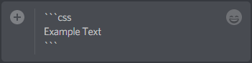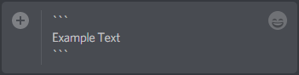

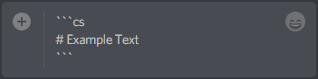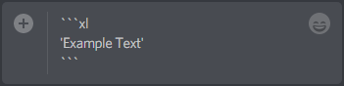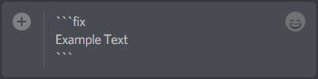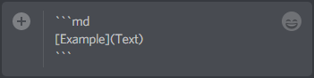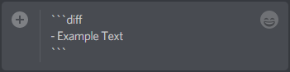

1. **Copyright © 2019** [**Jackson Roy Cope**](https://www.youtube.com/channel/UCe6MiDld2qEdtI8xLeobNnQ)**. All Rights Reserved.**